AudioCompass
A technology-evaluation program for the visually-impaired sailor
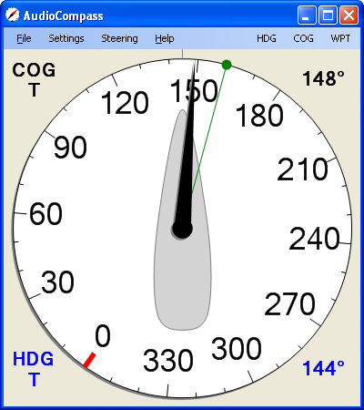

About AudioCompass
AudioCompass is a demonstration program from Four Fathom LLC, and is to be used in the development of programs for the visually-impaired sailor. AudioCompass is a simple program: it connects to a vessel’s NMEA-0183 data network, and displays heading, course, and waypoint information on a compass dial. Audio tones are generated to assist in the steering of the boat, and speech annunciation is provided for the relevant navigation data.
AudioCompass provides a simple keypad-driven method available for control of the program, with appropriate speech prompting. The current implementation of these features is rudimentary at best.
AudioCompass does not display speed, wind, depth, or many other navigation parameters. This is in large part from a desire to keep this a simple evaluation program. Additional capability will be added as the user interface is refined.
AudioCompass is designed to run under the Windows operating system.
AudioCompass is incomplete and relatively untested – there will be bugs. AudioCompass will probably not be suitable for your actual navigation needs. Four Fathom LLC is not responsible for any loss or damage resulting from the use of AudioCompass.
AudioCompass is provided at no cost for non-commercial use.

Changes from Previous Versions
Version 0.1.0.4 : Added On –Course (Silent) notifications Off–Course (Alert) controls.
Version 0.1.0.5 : (March 30, 2011)
- Added “Single Beep” steering feedback option
- Added main-window steering control menu-items
- Added heading-difference feedback to steering calculations in COG and HDG mode.

Installation
The AudioCompass program and documentation can be downloaded from the Four Fathom website: http://www.fourfathom.com.
This program requires the Microsoft “.NET” environment. If this is not installed, the AudioCompass setup process will offer to download and install the .NET package from the Microsoft website.

Using AudioCompass

Connections
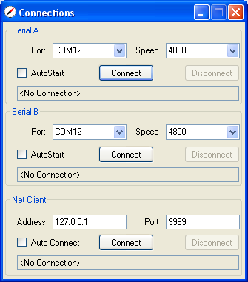
Once AudioCompass is installed, it needs to be connected to a NMEA-0183 data source. There are two available serial port interfaces, and one TCP/IP network interface.
- Serial Port – port and speed are selectable. Parity, bits, and stopbits are fixed at N, 8, 1.
- Net Client – address and port selectable
Once a connection has been attempted, AudioCompass will monitor the interface for data activity. If the connection is idle for ten seconds, AudioCompass will automatically disconnect and then attempt to reconnect.
If the AutoStart box is checked, when AudioCompass starts it will attempt to the previously-used connection.
Data from all three interfaces is combined and processed identically.

Settings : Sounds and Speech
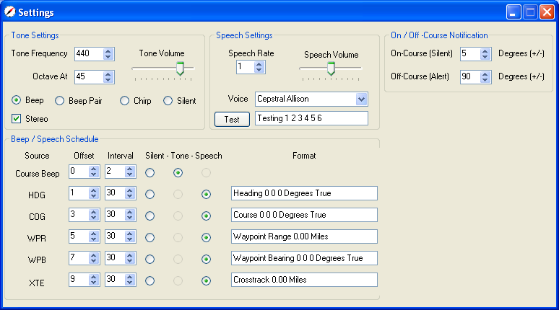

Course Beep / Chirp
Once a desired heading or course has been selected, the steering error will be indicated by a selectable audio tone:
- A single beep: low frequency means “turn to port”, high frequency means “turn to starboard”.
- A pair of beeps: The frequency difference between the two beeps increases with the course error. A “high-low” sequence beans “turn to port”, a “low-high” means “turn to starboard”.
- A frequency chirp: When on-course, this is a single-frequency beep. As the course-error increases, the beep will become a frequency-swept chirp. A “high-low” chirp beans “turn to port”, “low-high” means “turn to starboard”.
These tones repeat at a rate selected by the Beep / Speech Schedule - Course Beep controls.
The tone frequency is set using the Tone Frequency control. This establishes a center frequency – the tones will range above and below this value.
The spread between the port/starboard beep/chirp frequencies can be set with the Octave At control. The default is 90 degrees: when the steering error is 90 degrees, the two tones will be an octave apart, and when the steering error is 180 degrees the frequency ratio will be two octaves. When the single-beep option is selected, the beep frequencies are set by the combination of the Octave At and On-Course (Silent) controls.
There will be no course beep until a desired course or heading has been selected via the Steering window.

Speech Settings
AudioCompass uses the built-in Windows text-to-speech capabilities. The Speech Rate control sets the speed of the speech (0 = slow, 5 = fast). Speech Volume controls the volume.
The Voice control selects from the installed voices. Your computer should come with one or more voices; additional voices can be obtained from several sources (Cepstral, others?). Note that some allegedly installed voices may not actually work.
The Format fields provide the ability to customize the speech output.

On / Off –Course Notification
The On-Course (Silent) control can be used to silence the steering error tones when the course-error is less than a particular amount. When set to zero, the tones will always be generated.
The Off-Course (Alert) control will cause an “Alert” tone to be generated when the course-error exceeds a set amount. When set to zero, no alert will be generated. The On-Course (Silent) setting overrides the Off-Course (Alert) setting. The alert tone is a distinctive “doubled” version of the regular tones.

Beep / Speech Schedule
These tones, and the speech announcements, are scheduled using the Offset and Interval controls. AudioCompass allows sounds to be scheduled at one-second resolution over a sixty-second cycle. As shown above, the Course Beep will occur at 0, 2, 4, 6 … 56, 58 seconds. The HDG announcement will occur at 1 and 31 seconds. Offset must be less than Interval.
Future versions of AudioCompass will have more sophisticated scheduling capabilities, including the ability to set alarm conditions.

Settings : Filters
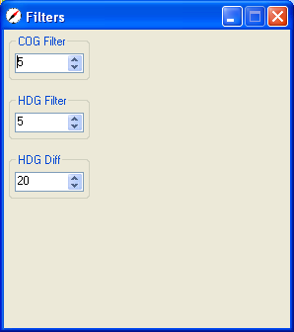
AudioCompass provides simple filters to reduce the “noise” from the various data sources. Setting a filter to “0” results in no filtering at all. Setting it to “20” means that changed data will reach 50% of the final value in ten seconds and 100% of the final value in twenty seconds. Heavy filtering gives slow response.
The HDG Diff filter deserves special mention. When steering to COG or to Waypoint the steering error reported by the Navsystem instruments may be sluggish, as it is sourced by the GPS-derived COG. To provide improved steering feedback, instantaneous changes in heading may be incorporated in the steering error calculations. The HDG Diff control setting determines the amount of heading change that is added. A value of zero will provide no heading information, and a value of 20 will provide maximum.
The appropriate settings for each of these filters will depend on your electronics, the conditions, your boat, and your own preferences. Experiment!

Settings: Restore Defaults
AudioCompass saves most user-selected options and settings when the program closes, and re-loads these the next time it is started. The Restore Defaults option will cause the settings defaults to be loaded when the program is next run.

Steering
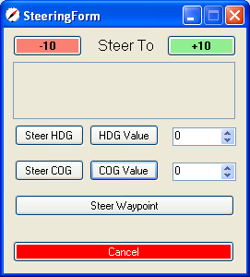
The Steering window is used to select the desired heading or course to steer.
The Steer HDG and Steer COG buttons select the current heading or course.
The HDG Value and COG Value buttons select the desired heading or course from the adjacent controls.
Steer Waypoint selects the current waypoint bearing as the Course to Steer. If this bearing is changed (at the chartplotter, for example), the AudioCompass Course to Steer will reflect the change.
The -10 and +10 buttons can be used to adjust the course or heading to steer.
The Cancel button cancels any previously-set Course to Steer.

Main Window Steering Controls
Many of these steering controls are accessible from the main window. Notice the HDG, COG, and WPT menu items below:
Clicking any of these, or using the keypad shortcuts (described later in this document) will activate steering feedback operation. When active, the red dot on the compass dial indicates the course or heading to steer, and the audio feedback is being generated.
When active, the main window menu changes as shown below:
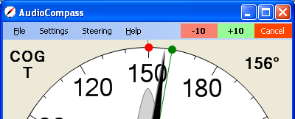
Notice the -10, +10 and Cancel controls.
The green line and dot indicate an active waypoint. When the range to waypoint is less than one nautical mile, the green dot will become bigger and slide towards the center of the compass dial as shown below.
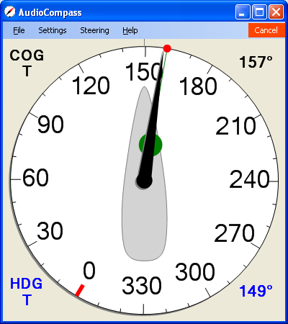

Debug
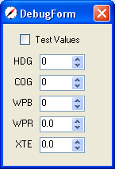
The contents of the Debug window will change from version to version. In the current program, checking the Test Values box lets you control the values for the displayed parameters. This provides the ability to evaluate (to a small degree) the operation of AudioCompass in the absence of an outside NMEA data source.

Keypad-Driven Steering
AudioCompass has rudimentary keypad control of steering and tone feedback:
- Enter : enters the keypad control mode
- Backspace : exits keypad control mode
- 0 : Cancel Steering
- 1 : Steer to current heading
- 2 : Steer to current COG
- 3 : Steer to Waypoint
- 4 : Increase tone off-course sensitivity
- 5 : Reduce tone off-course sensitivity
- 6 : Single Beep mode
- 7 : Chirp mode
- 8 : Beep-pair mode
- 9 : Silent
- ( : Subtract 1 degree from course to steer
- ) : Add 1 degree from course to steer
- / : Subtract 10 degrees from course to steer
- - : Add 10 degrees from course to steer
These keys are chosen to be conveniently accessed on the Logitech N305 wireless keypad, but any keypad or keyboard should work.

Future Features
We look forward to feedback and suggestions.
Join the “AudioNav” Yahoo discussion group ( http://groups.yahoo.com/group/AudioNav )to participate in the development of AudioCompass and other programs.

